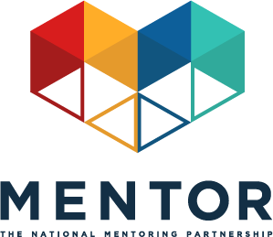
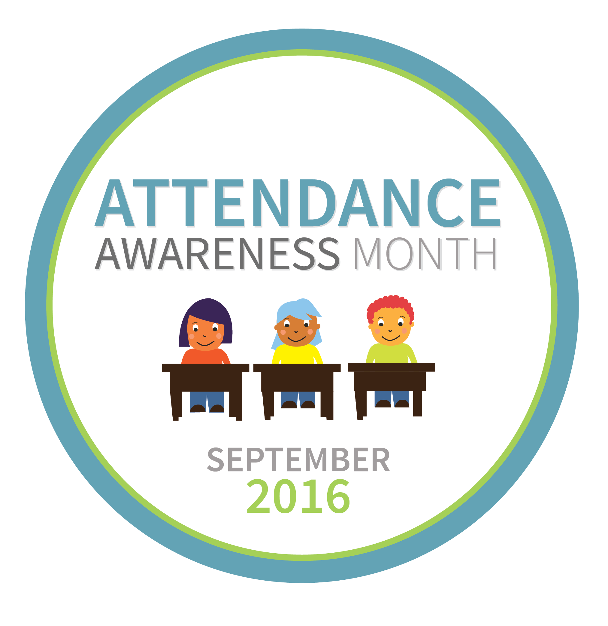

Attendance Awareness Month: September 2016
Toolkit: Mentoring In Real Life & Attendance Week - September 19-25, 2016
This September will mark the fifth annual Attendance Awareness Month (AAM) Campaign —an opportunity to rally your community, advocates, policymakers, volunteers, funders and supporters around the importance of attendance and its role in academic achievement! The campaign is spearheaded by Attendance Works, a national and state initiative that promotes better policy and practice around school attendance, and America’s Promise Alliance, Campaign for Grade-Level Reading, Everyone Graduates Center, Get Schooled, Healthy Schools Campaign, Points of Light, and United Way Worldwide and is supported by a growing list of other organizations. MENTOR: The National Mentoring Partnership (MENTOR) is proud to continue to serve as an AAM convening partner along with a diverse group of organizations.
Opportunity
Attendance Awareness Month provides MENTOR, our network of affiliate Mentoring Partnerships, mentoring programs, youth serving organizations, schools and all campaign partners with an opportunity to have a voice in a public dialogue about academic achievement led by influential education and youth development stakeholders.
Studies of formal mentoring programs have shown:
- Students who meet regularly with their mentors are 52 percent less likely than their peers to skip a day of school.
- Students who meet regularly with their mentors are 37 percent less likely than their peers to skip a class.
- Students at-risk for not graduating were 36 percent more likely to aspire to enroll in and graduate from college if they had a mentor.
- Youth who had a mentor growing up are 55 percent more likely to later be enrolled in college.
To strengthen this opportunity, MENTOR has worked with the campaign organizers to designate the week of September 19, 2016, as Mentoring In Real Life & Attendance Week! We have provided mentoring-specific social media messages to be distributed to all campaign convening and collaborating partners to help amplify the message that quality mentoring can be instrumental to attendance and academic success. The campaign organizers are also emphasizing the important role mentoring can play in improving attendance, including referencing MENTOR resources in the Attendance Awareness campaign toolkit.
By participating in Mentoring In Real Life & Attendance Week you can:
- Increase awareness about how quality mentoring can be leveraged as a strategy to improve attendance and thereby improve academic achievement.
- Reach new audiences tracking issues related to education, academic achievement and dropout and graduation rates.
- Engage current audiences with mentoring-specific content tied to a broader, timely campaign.
Key Mentoring & Attendance Messaging:
MENTOR’s The Mentoring Effect report shows that mentoring has a significant impact on academic achievement. The report’s nationally representative survey of young people ages 18-21 found that those who were at-risk for not graduating high school but who had a mentor were 55 percent more likely to be enrolled in college.
- Quality mentoring is proven to increase attendance by reducing the likelihood of students skipping class.
- Students who faced many challenges to graduation, including attendance, but who had a mentor were more likely to aspire to go to college, participate in sports and activities, and volunteer in their communities.
- Mentors can help foster and encourage a positive academic future by stressing the importance of attendance.
- Creating and maintaining positive connections between adults and youth is a key ingredient in each young person’s social, emotional, and academic development.
You can leverage this opportunity to link quality mentoring attendance outcomes and broader academic outcomes throughout the month of September by:
- Incorporating the campaign messages and mentoring messages into scheduled events, speaking engagements and programming.
- Sending an e-blast about this effort about attendance to your supporters, programs, policymakers, education contacts and even funders.
- Writing an article for your organization’s blog.
- Submitting an op-ed or a letter-to-the-editor to your local newspaper.
- Hosting a special event that focuses on attendance awareness and the importance of going to school every day.

Mentoring In Real Life & Attendance Week on Social Media
By collectively driving our social media conversations about mentoring and attendance during the week of September 19, we’ll have a better chance at ensuring the broad attendance awareness audience hears our message. Sample Tweets, Facebook, Instagram and LinkedIn posts that link mentoring to attendance outcomes are listed below.
The Attendance Awareness Campaign also has additional sample social media messages about attendance. Remember to incorporate #SchoolEveryDay and #MentorIRL hashtags if you write original tweets! And don’t forget to join us for our Mentoring In Real Life & Attendance Week Twitter chat Wednesday, September 21 at 3 p.m. ET/12 p.m. PT.
Sample Tweets
- September is Attendance Awareness Month! We support #SchoolEveryDay with @attendanceworks & @MentorNational. bit.ly/SePfuo #MentorIRL
- #Mentors can help promote attendance by being a real life support. #MentorIRL. bit.ly/1WkOr0C @attendanceworks #SchoolEveryDay
- #Mentors can help students foster positive attitudes toward school bit.ly/1WkOr0C @attendanceworks #SchoolEveryDay #MentorIRL
- #Mentored at-risk youth are 81% more likely to join in activities. bit.ly/1PXFB8f@attendanceworks #SchoolEveryDay #MentorIRL
- #Mentoring can help keep kids in school & lower the dropout rate. bit.ly/1WkOr0C @attendanceworks #SchoolEveryDay #MentorIRL
- #Mentored at-risk youth are 55% more likely to be college enrolled bit.ly/1PXFB8@attendanceworks #SchoolEveryDay #MentorIRL
- Students with #mentors are 37% less likely to skip class. bit.ly/1PXFB8@attendanceworks #SchoolEveryDay #MentorIRL
- RT if you had a #mentor who supported your academic success! bit.ly/1WkOr0C @attendanceworks #SchoolEveryDay #MentorIRL
- #Mentors can help students navigate academic challenges that arise. bit.ly/1WkOr0C @attendanceworks #SchoolEveryDay #MentorIRL
- #How do you help youth in your life feel positive about school? bit.ly/SePfuo @attendanceworks #SchoolEveryDay #MentorIRL
- Students with #mentors are 52% less likely to skip a day of school. bit.ly/1WkOr0C @attendanceworks #SchoolEveryDay #MentorIRL
- Quality #mentoring is proven to increase attendance. bit.ly/1WkOr0C @attendanceworks #SchoolEveryDay #MentorIRL
- Every 26 seconds, a student drops out. #Mentoring can change that. bit.ly/1WkOr0C @attendanceworks #SchoolEveryDay #MentorIRL
- #Mentored at-risk students are 36% more likely to stay in school. bit.ly/1PXFB8@attendanceworks #SchoolEveryDay #MentorIRL
- How do you stress importance of attendance to youth in your life? bit.ly/1WkOr0C @attendanceworks #SchoolEveryDay #MentorIRL
- The truth behind 4 common school attendance myths. bit.ly/1rd33E0 @attendanceworks #SchoolEveryDay #MentorIRL
- RT if you believe that EVERY school day counts! bit.ly/SePfuo @attendanceworks #SchoolEveryDay #MentorIRL
Sample Facebook/LinkedIn Posts
- September is Attendance Awareness Month! [ORGANIZATION NAME] is working with Attendance Works and MENTOR: The National Mentoring Partnership to raise awareness and help decrease chronic absence in our schools today. Learn more about Attendance Awareness Month and how mentors can help students stay connected to school: http://awareness.attendanceworks.org #MentorIRL
- Mentoring is a great way to promote education and has been proven to increase attendance in mentees. Students who meet regularly with their mentors are 52% less likely than their peers to skip a day of school and 55% more likely to aspire to enroll in college. By having a positive impact on just one student’s attendance, mentors have a positive effect on learning in the classroom for all students. Learn more about mentoring and academic achievement here: http://awareness.attendanceworks.org/partners/ #MentorIRL #SchoolEveryDay
Sample Instagram Post

- #Mentoring is proven to help promote education and reduce student absences in communities all over the country. When kids are in school and learning our communities grow stronger. Learn more about what you can do to help the youth in your life feel positive about school. #MentorIRL http://awareness.attendanceworks.org/

Download the following In Real Life & Attendance Week memes and share them on social media, along with the sample messaging provided above.
- 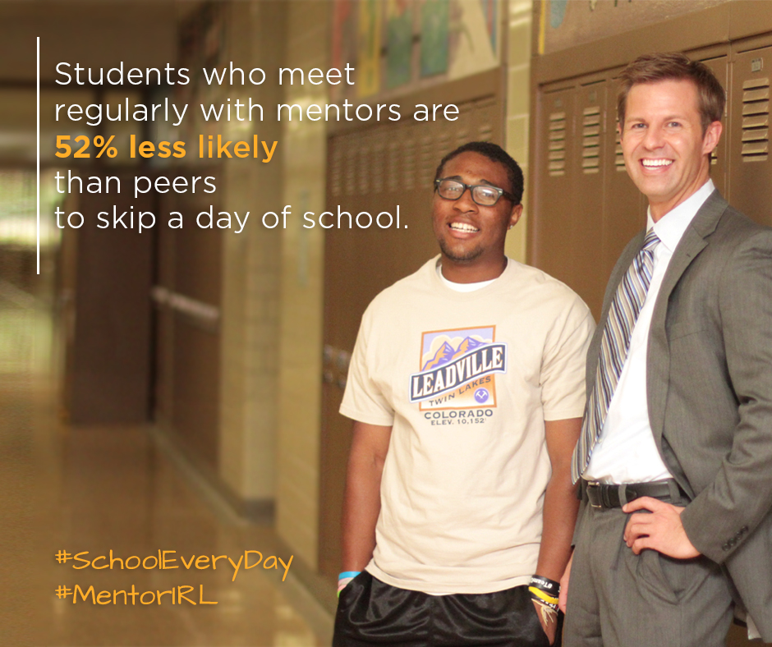
- 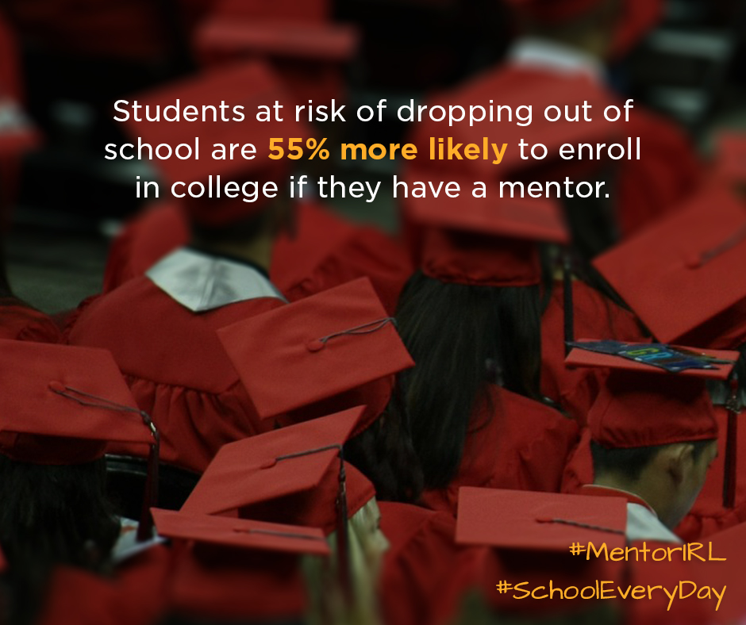
- 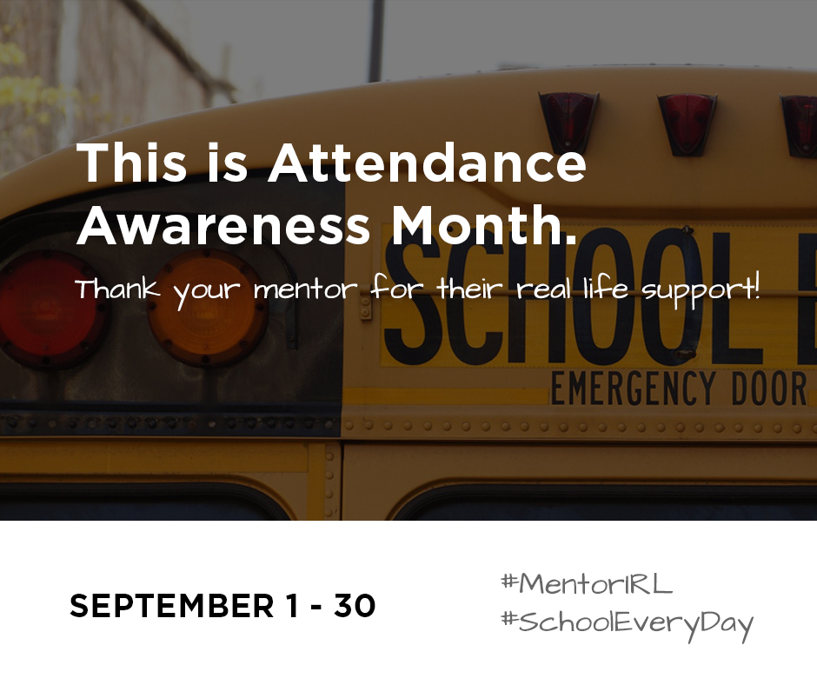
- 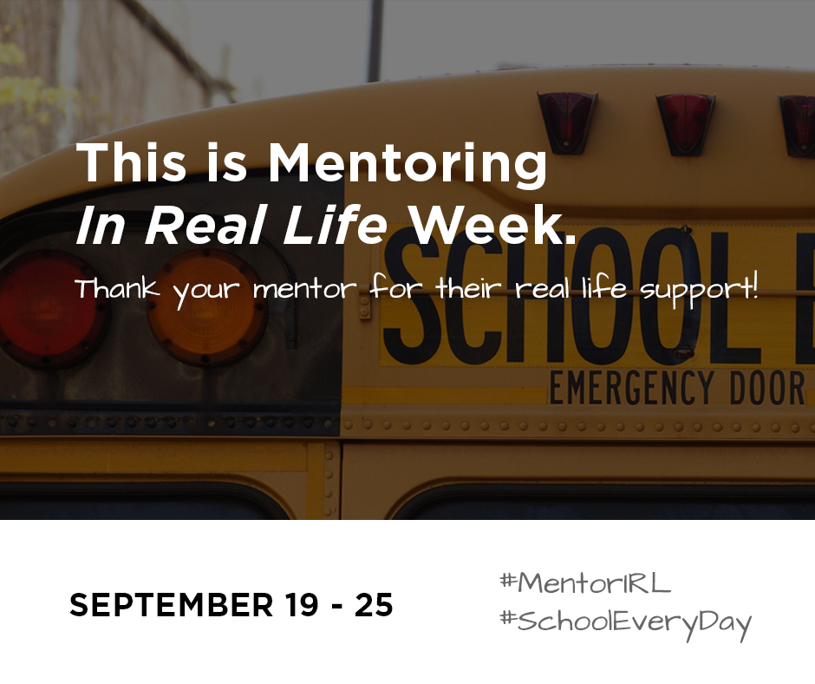
- 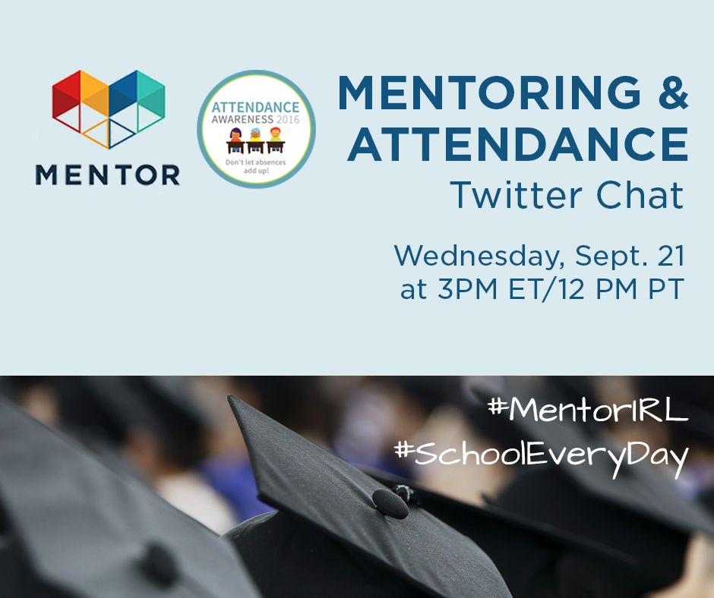

How to participate leading up to and throughout the month of September:
Participation throughout the month is easy! The Attendance Awareness Month campaign website has a wide range of materials, tools, and activities posted.
Here are a few quick links to some of the resources you may find most useful:
- Join the next campaign webinar: Collective Action: Taking a Cross-Sector Approach. It’s on August 16 from 11-12:30pm PT / 2-3:30pm ET, and speakers from San Francisco, Omaha and Austin will discuss what it looks like when partners from various sectors such as education, health, housing, justice and business pool their resources to help families get their children to school every day.
- Download and post the design materials to show your organization supports Attendance Awareness Month along with the memes above (Facebook cover image, website badge, and flyer and banner art).
- On Twitter, follow and mention @AttendanceWorks and @MentorNational and on Facebook, like the Attendance Works and MENTOR page.
- Use #SchoolEveryDay, #AttendanceWorks along with #MentorIRL hashtags to ensure your tweets are part of this conversation.
- Post your activities and other local events on this interactive map.
- Find more grassroots activities and resources in the full web-based campaign toolkit Count Us In!
- Sign up for ongoing updates from the Attendance Awareness Month campaign.

