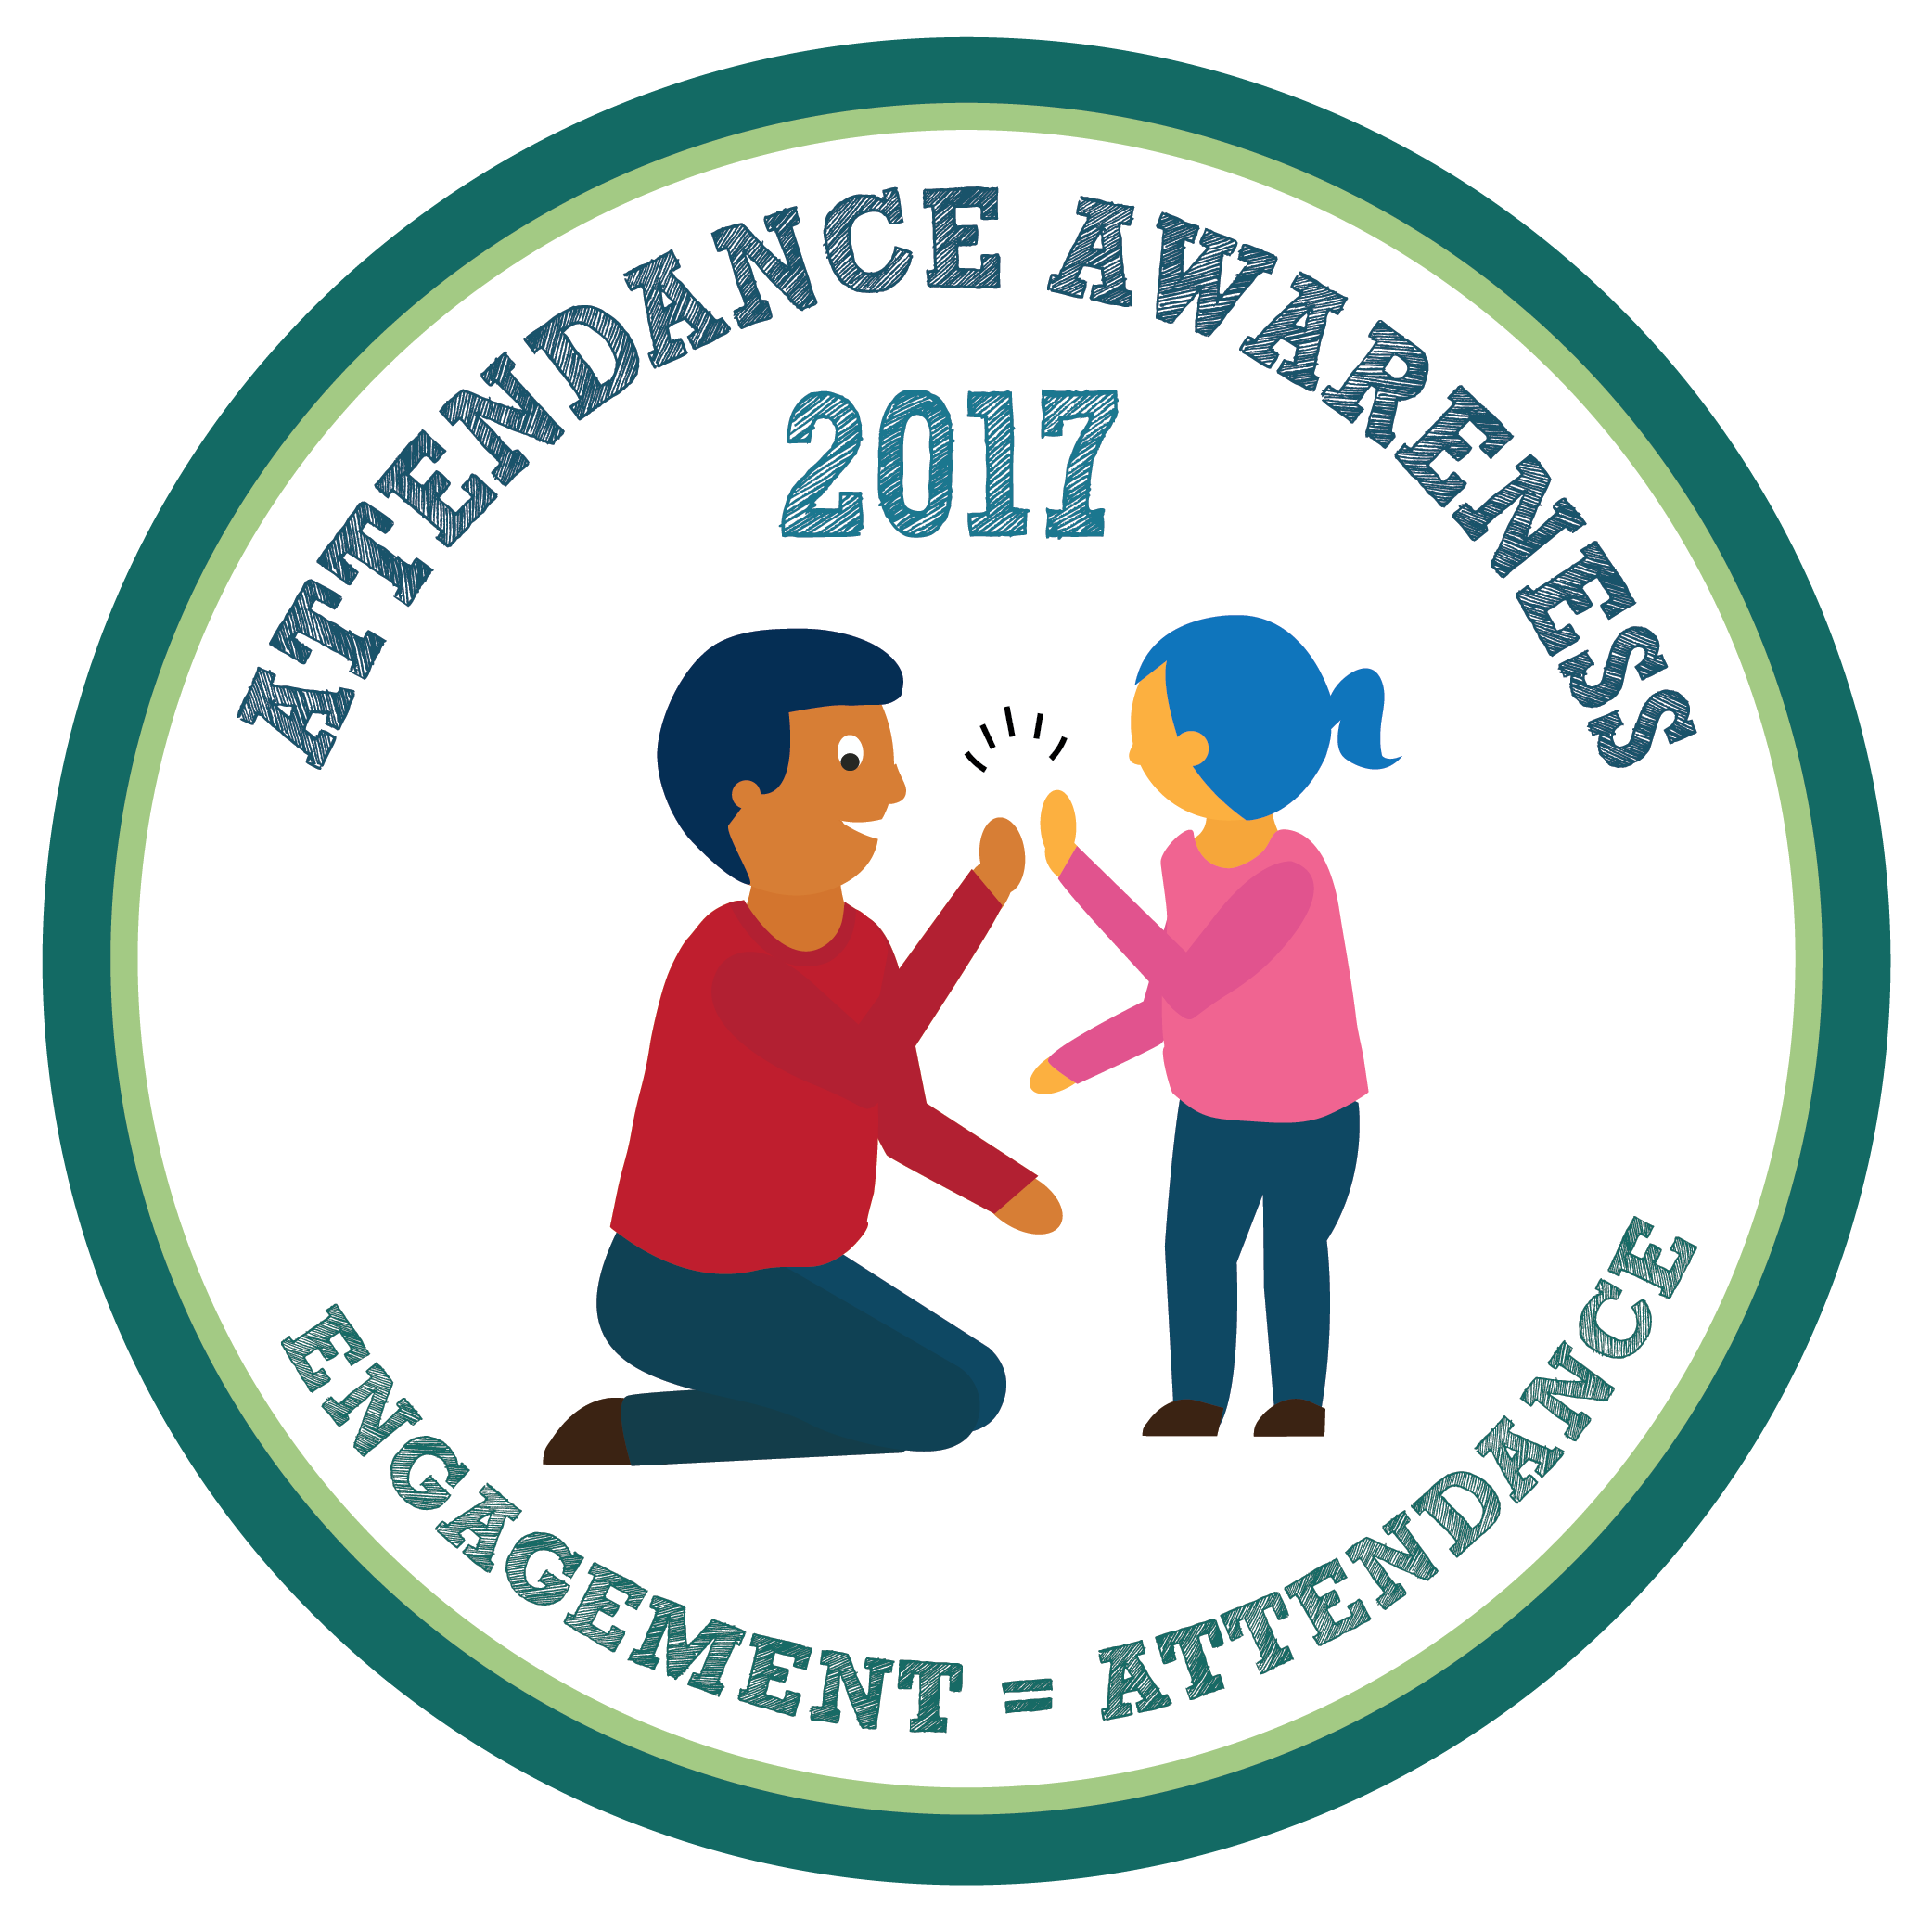
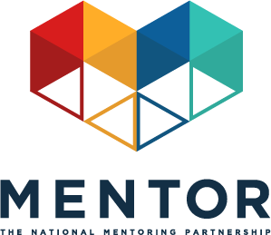

Attendance Awareness Month: September 2017
Toolkit: Mentoring In Real Life & Attendance Week - September 11-17, 2017
This September will mark the sixth annual Attendance Awareness Month (AAM) Campaign —an opportunity to rally your community, advocates, policymakers, volunteers, funders and supporters around the importance of attendance and its role in academic achievement! The campaign is spearheaded by Attendance Works, a national and state initiative that promotes better policy and practice around school attendance. MENTOR: The National Mentoring Partnership (MENTOR) is proud to continue to serve as an AAM national convening partner along with a diverse group of organizations.
Opportunity
Attendance Awareness Month provides MENTOR, its Affiliates, mentoring programs, youth serving organizations, schools and all campaign partners with an opportunity to have a voice in a public dialogue about academic achievement led by influential education and youth development stakeholders.
This year, the week of September 11, 2017 is Mentoring In Real Life & Attendance Week! We have provided mentoring-specific social media messages to be distributed to all campaign partners to help amplify the message that quality mentoring can be instrumental to attendance and academic success. The campaign organizers are also emphasizing the important role mentoring can play in improving attendance, including referencing MENTOR resources in the Attendance Awareness campaign toolkit.
By participating in Mentoring In Real Life & Attendance Week you can help increase awareness about how quality mentoring can be leveraged as a strategy to improve attendance and thereby improve academic achievement.
Mentoring In Real Life & Attendance Week on Social Media
By collectively driving our social media conversations about mentoring and attendance during the week of September 11th, we’ll have a better chance at ensuring the broad attendance awareness audience hears our message. Sample Tweets, Facebook, Instagram and LinkedIn posts that link mentoring to attendance outcomes are listed below.
The Attendance Awareness Campaign also has additional sample social media messages about attendance. Remember to incorporate #SchoolEveryDay and #MentorIRL hashtags if you write original tweets! And don’t forget to join us for our Mentoring In Real Life & Attendance Week Twitter chat Thursday, September 14 at 3 p.m. ET/12 p.m. PT.
Sample Tweets
- September is Attendance Awareness Month! We support #SchoolEveryDay w/ @attendanceworks & @MentorNational bit.ly/SePfuo #MentorIRL
- #Mentors can help promote attendance by being a real life support #MentorIRL bit.ly/1WkOr0C @attendanceworks #SchoolEveryDay
- Become a #MentorIRL to help increase attendance bit.ly/1WkOr0C @attendanceworks #SchoolEveryDay
- #Mentored at-risk youth are 81% more likely to join in activities bit.ly/1PXFB8f @attendanceworks #SchoolEveryDay #MentorIRL
- #Mentored at-risk youth are 55% more likely to be college enrolled bit.ly/1PXFB8f @attendanceworks #SchoolEveryDay #MentorIRL
- Students with #mentors are 37% less likely to skip class http://bit.ly/2gq1DJ2 @attendanceworks #SchoolEveryDay #MentorIRL
- Students with #mentors are 52% less likely to skip a day of school http://bit.ly/2gq1DJ2 @attendanceworks #SchoolEveryDay #MentorIRL
- #Mentored at-risk students are 36% more likely to stay in school bit.ly/1PXFB8f @attendanceworks #SchoolEveryDay #MentorIRL
- Quality #mentoring is proven to increase attendance. bit.ly/1WkOr0C @attendanceworks #SchoolEveryDay #MentorIRL
- RT if you believe that EVERY school day counts! bit.ly/SePfuo @attendanceworks #SchoolEveryDay #MentorIRL
- How do you help youth in your life feel positive about school? bit.ly/SePfuo @attendanceworks #SchoolEveryDay #MentorIRL

Sample Facebook/LinkedIn Posts
- September is Attendance Awareness Month! [ORGANIZATION NAME] is working with Attendance Works and MENTOR: The National Mentoring Partnership to raise awareness and help decrease chronic absenteeism in our schools today. Learn more about Attendance Awareness Month and how mentors can help students stay connected to school: http://awareness.attendanceworks.org #MentorIRL #SchoolEveryDay
- Mentoring is a great way to promote education and has been proven to increase attendance in mentees. Students who meet regularly with their mentors are 52% less likely than their peers to skip a day of school and 55% more likely to aspire to enroll in college. By having a positive impact on just one student’s attendance, mentors can help increase learning in the classroom for all students. Learn more about mentoring and academic achievement here: http://awareness.attendanceworks.org/resources/count-us-toolkit-2017/can-identify-help-students-poor-attendance/reach-absent-students-families/ #MentorIRL #SchoolEveryDay
Sample Instagram Post
Text:

- #Mentoring is proven to help promote education and reduce student absences. When kids are in school and learning, our communities grow stronger. Learn more about what you can do to help the youth in your life feel positive about school. #MentorIRL #SchoolEveryDay http://awareness.attendanceworks.org/

Graphics:
Download the following In Real Life & Attendance Week memes and share them on social media, along with the sample messaging provided above.
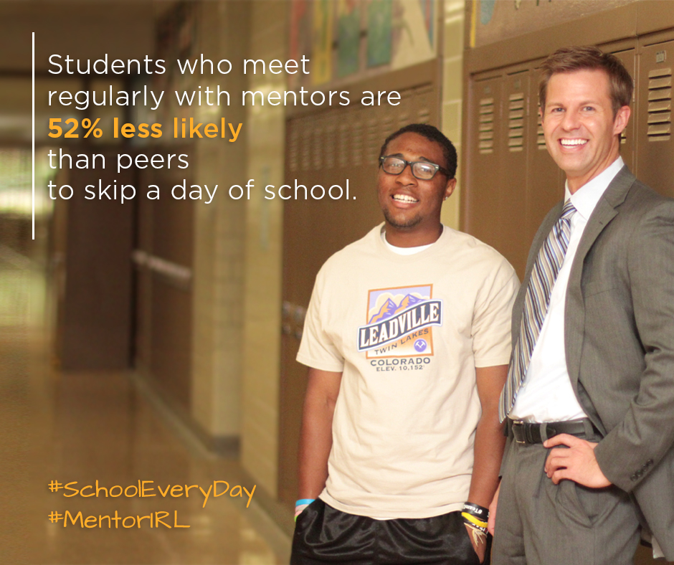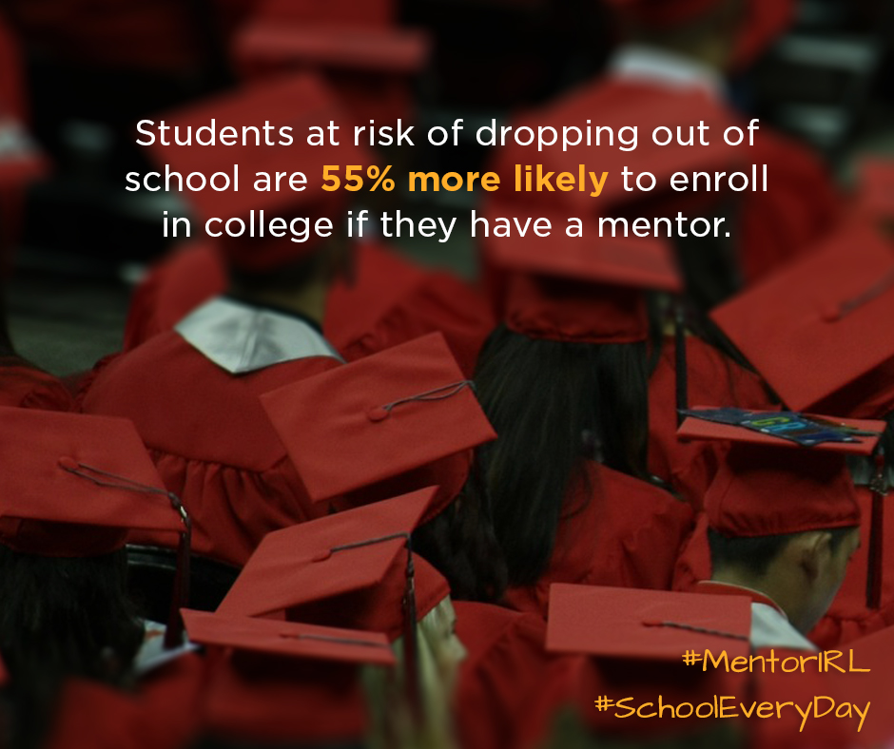
How to participate throughout the month of September:
Participation throughout the month is easy! The Attendance Awareness Month campaign website has a wide range of materials, tools, and activities posted.
Here are a few quick links to some of the resources you may find most useful:
- Download and post the materials (Facebook cover image, website badge, and flyer and banner art) to show your organization supports Attendance Awareness Month along with the memes above.
- On Twitter, follow and mention @AttendanceWorks and @MentorNational and on Facebook, like the Attendance Works , Attendance Awareness Campaign and MENTOR pages.
- Use #SchoolEveryDay, #AttendanceWorks along with #MentorIRL hashtags to ensure your tweets are part of this conversation.
- Post your activities and other local events on this interactive map.
- Find more grassroots activities and resources in the full web-based campaign toolkit Count Us In!
- Sign up for ongoing updates from the Attendance Awareness Month campaign.

