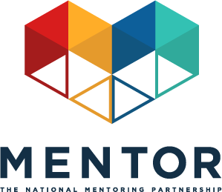
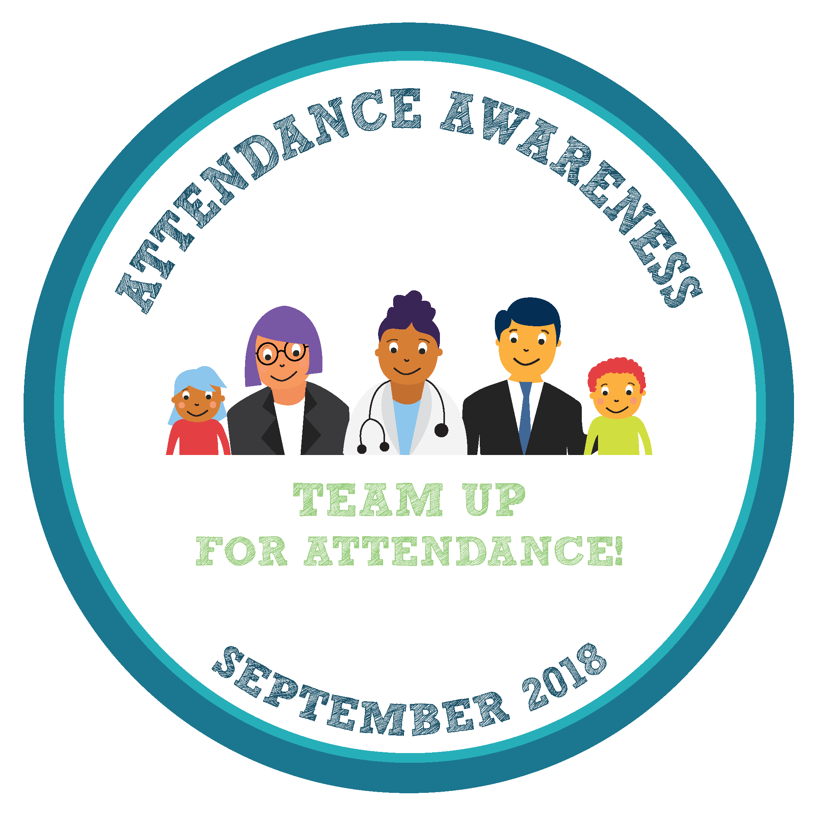

Toolkit: Mentoring In Real Life & Attendance Week
September 17-21, 2018
This September will mark the sixth annual Attendance Awareness Month (AAM) Campaign —an opportunity to rally your community, advocates, policymakers, volunteers, funders and supporters around the importance of attendance and its role in academic achievement! The campaign is spearheaded by Attendance Works, a national and state initiative that promotes better policy and practice around school attendance. MENTOR: The National Mentoring Partnership (MENTOR) is proud to continue to serve as an AAM national convening partner along with a diverse group of organizations.
Opportunity
This year, the week of September 17, 2018 is Mentoring In Real Life & Attendance Week! We have provided mentoring-specific social media messages to be distributed to all campaign partners to help amplify the message that quality mentoring can be instrumental to reducing chronic absence and academic success. The campaign organizers are also emphasizing the important role mentoring can play in improving attendance, including referencing MENTOR resources in the Attendance Awareness campaign toolkit.
Social Media Initiatives
By collectively driving our social media conversations about mentoring and attendance during the week of September 17, 2018 we’ll have a better chance at ensuring the broad attendance awareness audience hears our message. Sample Tweets, Facebook, Instagram and LinkedIn posts that link mentoring to attendance outcomes are listed below.
The Attendance Awareness Campaign also has additional sample social media messages about attendance. Remember to incorporate #MentorIRL and #SchoolEveryDay hashtags if you write original tweets! And don’t forget to join us for our Back to School Twitter Chat on Tuesday, September 18 at 3 p.m. ET/12 p.m. PT.

Sample Tweets
- September is Attendance Awareness Month! We support #SchoolEveryDay with @attendanceworks & @MENTORnational bit.ly/1oqfID7 #MentorIRL
- A quality #mentoring program strengthens school-wide strategies to boost attendance in #SchoolEveryDay Become a mentor! #MentorIRL bit.ly/1WkOr0C
- #Mentored at-risk youth are 81% more likely to join in sports and extracurricular activities bit.ly/1PXFB8f @attendanceworks #SchoolEveryDay #MentorIRL
- #Mentored at-risk youth are 55% more likely to be enrolled in college bit.ly/1WkOr0C @attendanceworks #SchoolEveryDay #MentorIRL
- Students with #mentors are 52% less likely to skip a day of school bit.ly/1oqfID7 @attendanceworks #SchoolEveryDay #MentorIRL
- Help young people to attend #SchoolEveryDay by becoming a #MentorIRL bit.ly/1WkOr0C @attendanceworks
- Mentors can help support youth in school by encouraging attendance bit.ly/1WkOr0C @attendanceworks #SchoolEveryDay #MentorIRL
- Mentoring has been proven to help increase attendance in school. Help young people succeed by becoming a #MentorIRL @attendanceworks #SchoolEveryDay bit.ly/1WkOr0C
- Learn about how you can play a role in making sure that all youth attend school regularly bit.ly/1oqfID7 @attendanceworks @MENTORnational #SchoolEveryDay #MentorIRL

Sample Facebook/LinkedIn Posts
- This September, learn how mentoring can encourage all youth to attend school regularly and how mentors and all supportive, caring adults can help lower chronic absenteeism: http://awareness.attendanceworks.org #MentorIRL #SchoolEveryDay
- This Attendance Awareness Month we look to mentors to support youth inside and outside of the classroom. Mentors can help promote education and encourage attendance for their mentees. Youth who meet regularly with their mentor are 52% less likely than their peers to skip a day of school. Mentoring can help reduce chronic absenteeism, which will have a positive impact on students’ academic achievement. Learn more about this here: http://bit.ly/2MWh0Yt #MentorIRL #SchoolEveryDay

Sample Instagram Post

Text: Nearly 8 million students face chronic absenteeism, putting them at risk for falling behind academically. Mentoring has been proven to help reduce chronic absenteeism so all youth have the opportunity to feel positive about their education. Learn more from Attendance Works #MentorIRL #SchoolEveryDay
Graphics: Download the following In Real Life memes and share them on social media, along with the sample messaging provided above.
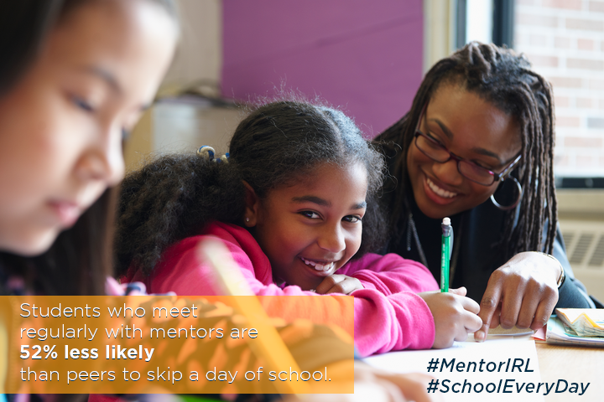
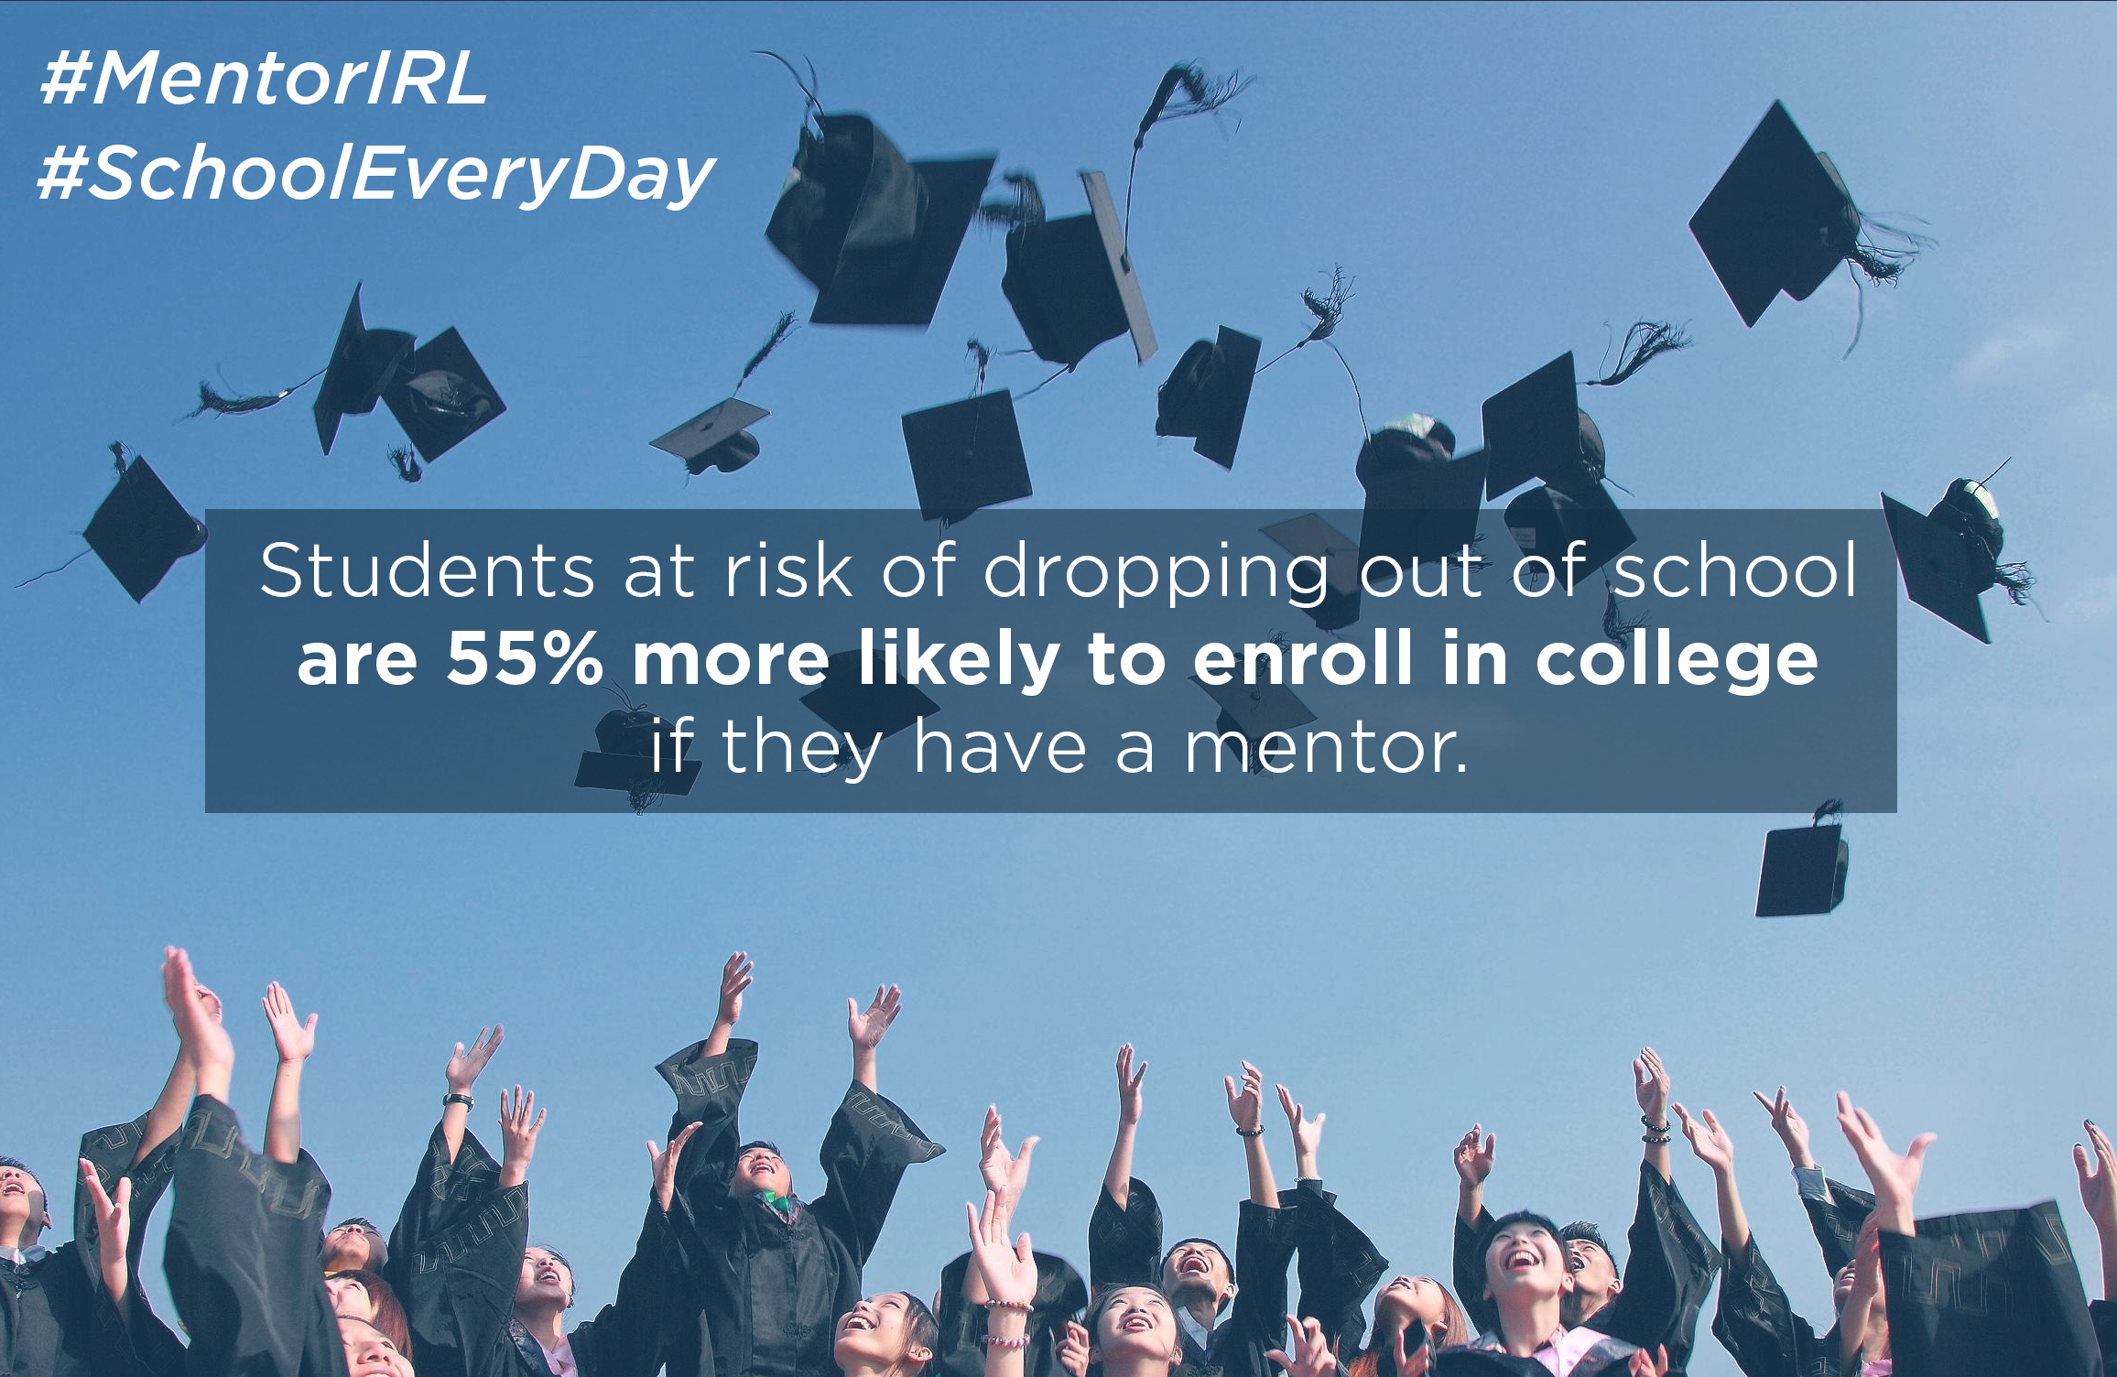

How to participate throughout the month of September:
Participation throughout the month is easy! The Attendance Awareness Month campaign website has a wide range of materials, tools, and activities posted.
Here are a few quick links to some of the resources you may find most useful:
- Download and post the materials (Facebook cover image, website badge, and flyer and banner art) to show your organization supports Attendance Awareness Month along with the memes above.
- On Twitter, follow and mention @AttendanceWorks and @MentorNational and on Facebook, like the Attendance Works , Attendance Awareness Campaign and MENTOR pages.
- Use #SchoolEveryDay and #MentorIRL hashtags to ensure your tweets are part of this conversation.
- Upload photos or videos to Share Your Story about attendance activities and other local events on the Attendance Awareness Campaign website.
- Find more grassroots activities and resources in the full web-based campaign toolkit Count Us In!
- Sign up for ongoing updates from the Attendance Awareness Month campaign.

