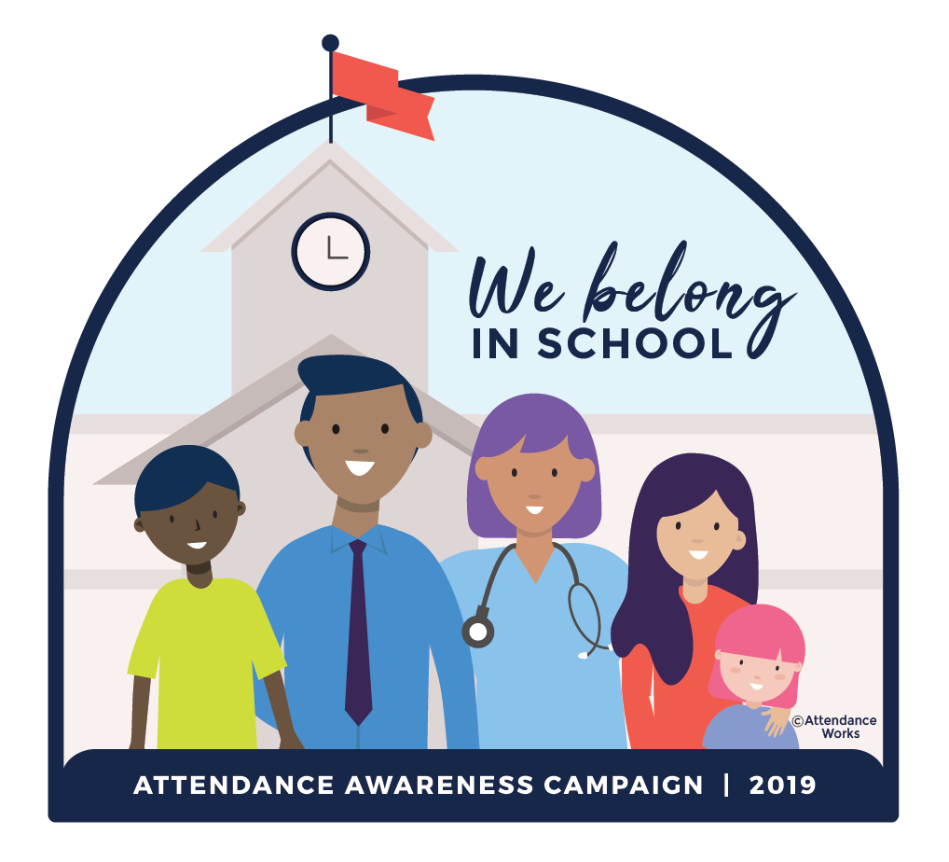
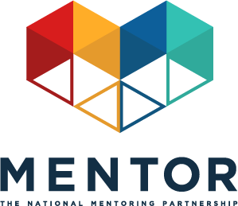

Toolkit: Mentoring In Real Life & Attendance Week
September 16-20, 2019

This September will mark the seventh annual Attendance Awareness Campaign (AAC) — an opportunity to rally your community, advocates, policymakers, volunteers, funders and supporters around the importance of attendance and its role in academic achievement! In 2019 we are encouraging everyone to remember that students are more likely to attend school if they feel emotionally and physically safe, connected and supported, and believe they can learn and achieve. Read the Campaign Key Messages to learn more.

The campaign is spearheaded by Attendance Works, a national and state initiative that promotes better policy and practice around school attendance. MENTOR: The National Mentoring Partnership (MENTOR) is proud to continue to serve as an AAC national convening partner along with a diverse group of organizations.

This year, the week of September 16, 2019 is Mentoring In Real Life & Attendance Week! We have provided mentoring-specific social media messages to be distributed to all campaign partners to help amplify the message that quality mentoring can be instrumental to reducing chronic absence and academic success. The campaign organizers are also emphasizing the important role mentoring can play in improving attendance, including referencing MENTOR resources in the Attendance Awareness campaign toolkit, Count Us In!
Social Media Initiatives:
By collectively driving our social media conversations about mentoring and attendance during the week of September 16, 2019 we’ll have a better chance at ensuring the broad attendance awareness audience hears our message. Sample Tweets, Facebook, Instagram and LinkedIn posts that link mentoring to attendance outcomes are listed below.

The Attendance Awareness Campaign also has additional sample social media messages and images about attendance. Remember to incorporate #MentorIRL and #SchoolEveryDay hashtags if you write original tweets! And don’t forget to join us for our Back to School Twitter Chat on Thursday, September 19 at 2 PM ET/ 11 AM PT.

Sample Tweets:

- September is Attendance Awareness Month! We support #SchoolEveryDay with @attendanceworks & @MENTORnational bit.ly/1oqfID7 #MentorIRL
- A quality #mentoring program strengthens school-wide strategies to boost attendance in #SchoolEveryDay. Become a #MentorIRL bit.ly/1oqfID7
- #Mentored youth are 81% more likely to join in sports and extracurricular activities bit.ly/1PXFB8f @attendanceworks @MENTORnational #SchoolEveryDay #MentorIRL
- #Mentored youth are 55% more likely to be enrolled in college bit.ly/1WkOr0C @attendanceworks @MENTORnational #SchoolEveryDay #MentorIRL
- Students with #mentors are 52% less likely to skip a day of school bit.ly/1oqfID7 @attendanceworks @MENTORnational #SchoolEveryDay #MentorIRL
- Help young people to attend #SchoolEveryDay by becoming a #MentorIRL at bit.ly/1WkOr0C @attendanceworks @MENTORnational
- Mentors can help support youth in school by encouraging attendance bit.ly/1oqfID7 @attendanceworks @MENTORnational #SchoolEveryDay #MentorIRL
- Mentoring has been proven to help increase attendance in school. Help young people succeed by becoming a #MentorIRL @attendanceworks @MENTORnational #SchoolEveryDay bit.ly/1WkOr0C
- Learn how you can play a role in making sure that all youth attend school regularly bit.ly/1oqfID7 @attendanceworks @MENTORnational #SchoolEveryDay #MentorIRL

Sample Facebook/LinkedIn Posts:

- This September, learn how mentoring can encourage all youth to attend school regularly and how mentors and all supportive, caring adults can help lower chronic absenteeism: http://awareness.attendanceworks.org #MentorIRL #SchoolEveryDay @MENTORnational
- During the Attendance Awareness Campaign, we look to mentors to support youth inside and outside of the classroom. Mentors can help promote education and encourage attendance for their mentees. Youth who meet regularly with their mentor are 52% less likely than their peers to skip a day of school. Mentoring can help reduce chronic absenteeism, which will have a positive impact on students’ academic achievement. Learn more about this here: http://bit.ly/2MWh0Yt #MentorIRL #SchoolEveryDay @MENTORnational

Sample Instagram Post:

Text: Nearly 8 million students face chronic absenteeism, putting them at risk for falling behind academically. Mentoring has been proven to help reduce chronic absenteeism so all youth have the opportunity to feel positive about their education. Learn more from Attendance Works @mentornmp #MentorIRL #SchoolEveryDay

Graphics: Download the following In Real Life memes and share them on social media, along with the sample messaging provided above.

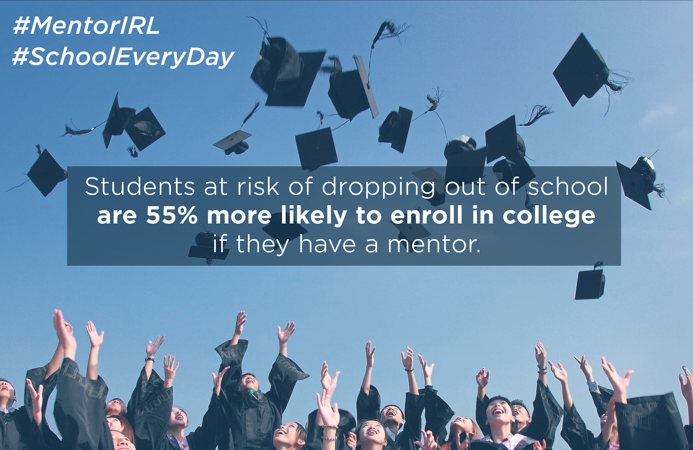
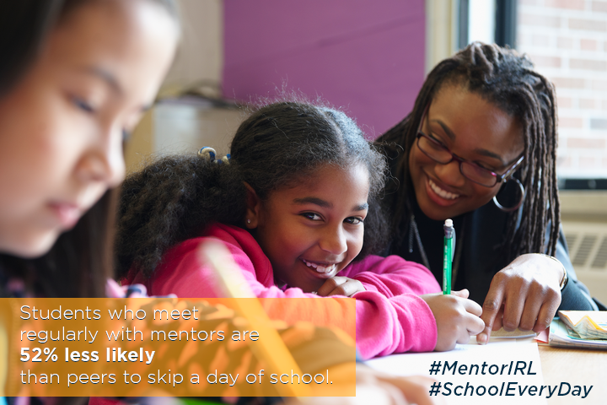

How to participate throughout the month of September:
Participation throughout the month is easy! The Attendance Awareness Campaign website has a wide range of materials, tools, and activities posted.
Here are a few quick links to some of the resources you may find most useful:
- Download and post the materials (Facebook cover image, website badge, and flyer and banner art) to show your organization supports the Attendance Awareness Campaign along with the memes above.
- On Twitter, follow and mention @AttendanceWorks and @MENTORnational and on Facebook, like the Attendance Works , Attendance Awareness Campaign and MENTOR pages.
- Use #SchoolEveryDay and #MentorIRL hashtags to ensure your tweets are part of this conversation.
- Upload photos or videos to Share Your Story about attendance activities and other local events on the Attendance Awareness Campaign website.
- Find more grassroots activities and resources in the full web-based campaign toolkit Count Us In!
- Sign up for ongoing updates from the Attendance Awareness Campaign.

