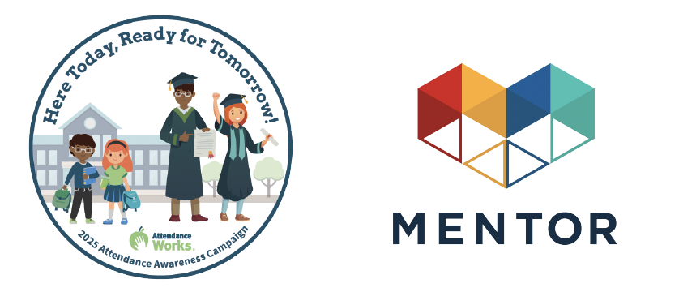

Toolkit: Youth Mentoring & Attendance Awareness Month

***September 2025***

This September will mark the thirteenth annual [Attendance Awareness Campaign (AAC](http://awareness.attendanceworks.org/)) — an opportunity to rally your community, advocates, policymakers, volunteers, funders and supporters around the importance of attendance and its role in academic achievement! This year’s campaign, ‘Here Today, Ready for Tomorrow’, serves as a reminder of the connection between school attendance, and the lives youth are able to build for themselves as a result. Read the [Campaign Key Messages](https://awareness.attendanceworks.org/resources/count-us-toolkit/what-are-the-key-messages-2/) to learn more.

The campaign is spearheaded by [Attendance Work](http://www.attendanceworks.org/)s, a national and state initiative that promotes better policy and practice around school attendance. [MENTOR](http://www.mentoring.org/) is proud to continue to serve as an AAC [national convening partner](http://awareness.attendanceworks.org/partners/) along with a diverse group of organizations.

We have provided mentoring-specific and general attendance awareness social media messages to be distributed to all campaign partners to help amplify the message that quality mentoring can be instrumental to reducing chronic absence and boosting student well-being and academic success. The campaign organizers are also emphasizing the important role mentoring can play in improving attendance, including referencing MENTOR resources in the Attendance Awareness campaign toolkit, [Count Us In!](https://awareness.attendanceworks.org/resources/count-us-toolkit-2019/)

**Sample Social Media Messaging:**

By collectively driving our social media conversations about mentoring and through September 2025, we’ll have a better chance of ensuring the broad attendance awareness audience hears our message. Sample social media posts that link mentoring to attendance outcomes are listed below. The Attendance Awareness Campaign also has additional [sample social media messages](https://awareness.attendanceworks.org/social-media-3/) and images about attendance and mentoring.

**Short Messaging (fewer than 280 characters):**

* Quality mentoring programs can strengthen school-wide strategies to boost attendance at school daily! Learn more at [bit.ly/1oqfID7](http://bit.ly/1oqfID7) <tag Attendance Works> <tag MENTORNational>
* Mentored youth are 75% more likely to have held a leadership position in a club or sports team. Learn more about how mentoring helps youth at [bit.ly/3HrZ0DA](http://bit.ly/3HrZ0DA) <tag Attendance Works> <tag MENTOR National>
* Mentors can help support youth in school by encouraging attendance & helping them in all facets of life: [bit.ly/3V055dq](http://bit.ly/3V055dq) <tag Attendance Works> <tag MENTOR National>
* Almost 25% of students face chronic absence, putting them at risk for falling behind academically and developmentally. Mentoring has been proven to help reduce chronic absence, so all youth can feel positive about their education. Learn more from Attendance Works at [bit.ly/1oqfID7](http://bit.ly/1oqfID7) <tag Attendance Works> <tag MENTOR National>
* This September, learn how mentoring can encourage all youth to attend school regularly and can help lower chronic absence: <http://awareness.attendanceworks.org> <tagAttendance Works> <tag MENTOR National>
* 🌱 All students benefit from a school-wide climate that supports relationship building. A tiered approach starts with that foundation—and offers more help when it’s needed. 📚 Learn more: https://www.attendanceworks.org/chronic-absence/addressing-chronic-absence/3-tiers-of-intervention/
* Making a difference in a child's attendance doesn’t necessarily call for extra work. Students are more likely to attend when they know someone cares that they show up. Teachers and staff can play a vital role in fostering a sense of connection to school. https://tinyurl.com/ypd6vuwx

**Long Messaging:**

* During Attendance Awareness Month and throughout the school year, we look to mentors to support youth inside and outside of the classroom. Mentors can help promote education and encourage attendance and engagement for their mentees. Youth who meet regularly with their mentor are 52% less likely than their peers to skip a day of school. Mentoring can help reduce chronic absence, which has a positive impact on students’ academic achievement. Learn more at: [bit.ly/3V055dq](http://bit.ly/3V055dq) <tag Attendance Works> <tag MENTOR National>
* 🌱 Building strong, trusting relationships with families is essential for fostering a sense of belonging at school. When families feel connected and supported, students are more likely to attend regularly and engage in learning. Schools can create this environment by partnering with families and listening to their concerns. Learn more about strategies to strengthen family engagement and improve attendance: https://tinyurl.com/ypd6vuwx

**How to participate throughout the month of September:**

Participation throughout the month is easy! The [Attendance Awareness Campaign](http://awareness.attendanceworks.org/) website has a wide range of materials, tools, and activities posted.

Here are a few quick links to some of the resources you may find most useful:

* [Download and post the materials](https://awareness.attendanceworks.org/resources/promotional-materials/) (graphics, website badges, banners, and more) to show that your organization supports the Attendance Awareness Campaign.
* Find more grassroots activities and resources in the full web-based campaign toolkit [Count Us In!](https://awareness.attendanceworks.org/resources/count-us-toolkit/)
* Sign up for [ongoing updates](http://awareness.attendanceworks.org/contact/aam-updates/) from the Attendance Awareness Campaign.
* Tag us using the social media handles below!
  + Facebook: [@MENTOR](https://www.facebook.com/MENTORnational) @AttendanceCounts
  + LinkedIn: [@MENTOR](https://www.linkedin.com/company/131953/admin/feed/posts/) @AttendanceWorks
  + Instagram: [@mentornmp](https://www.instagram.com/mentornmp/) @attendanceworks
  + Twitter/X: [@MENTORnational](https://x.com/MENTORnational) @attendanceworks