Team Up for Attendance: Working Together Matters!
Webinar Discussion Guide

Below are a suggested set of key questions to prompt discussion about what communities might do given insights shared during the Team Up for Attendance: Working Together Matters! webinar on May 8, 2018. Feel free to use some or all to prompt a rich conversation about how to take action.

1. Working Together: Each speaker on the webinar shared about a team approach to addressing chronic absence.

- To what extent does your school, district or community work together to address chronic absence?

- What are the benefits of a team approach?

2. Changing Context: At the beginning of the webinar, Hedy Chang spoke of the major shift in attendance policy as 36 states and the District of Columbia added some measure of chronic absence to the state plan to implement the Every Student Succeeds Act.

- What is happening in your state regarding ESSA implementation and how might it affect your community?

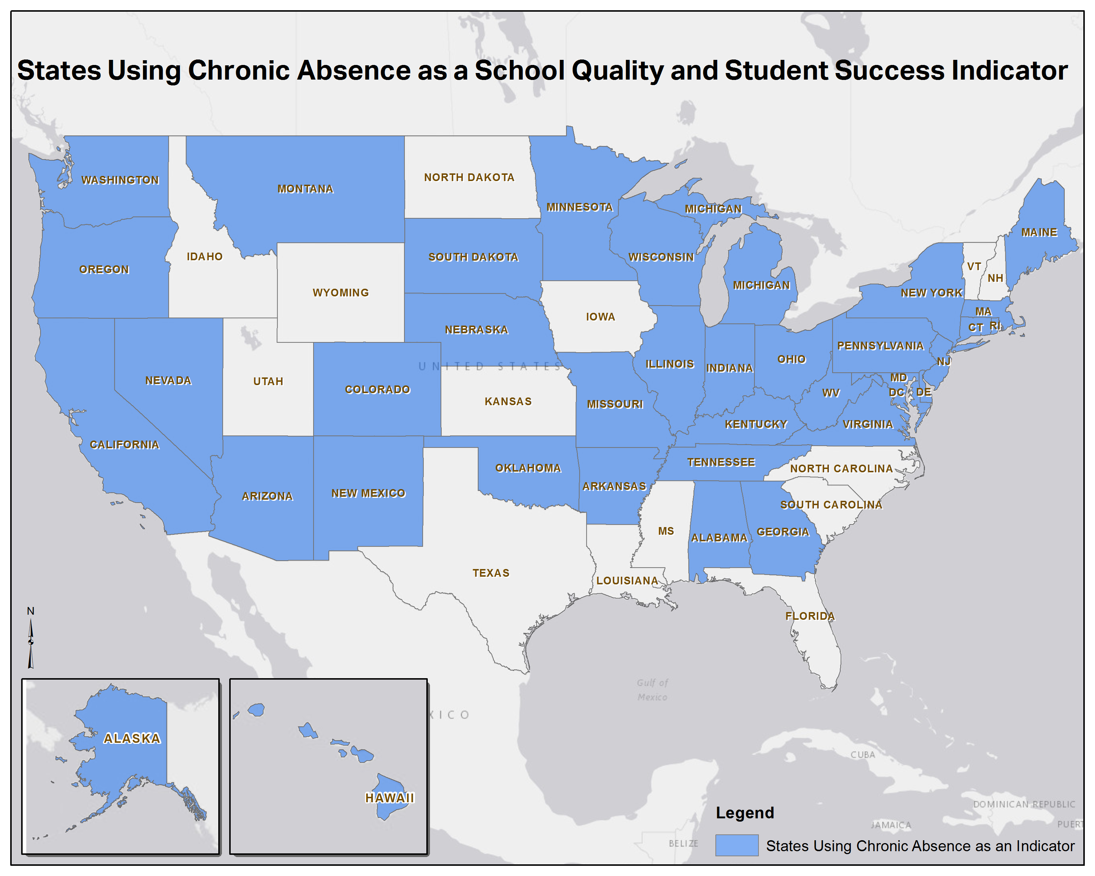

3. Leveraging Free Resources: Explore the 2018 Count Us In toolkit. You can find it at: http://awareness.attendanceworks.org/

- How might you tailor the free resources in the toolkit to address your community’s realities and celebrate Attendance Awareness Month 2018?

4. Learn more about chronic absence and how you can address it: Register for the Teaching Attendance Curriculum: http://www.attendanceworks.org/resources/teaching-attendance-curriculum/

- How might you use the Teaching Attendance Curriculum to support a team approach?

